Farmer Support and Advisory Portal

Asavari Tayal

Electrical and Computer Engineering

ECE 397 NA

Individual Study

Guided by John M. Hart

Principal Research Engineer

Beckman Institute

**Introduction**

The purpose of this project is to provide a practical method of implementation for the grain monitoring and quality testing efforts being made by the University of Illinois for smallholder farmers in the agricultural districts of Bihar, India. The portal aims to provide a support and advisory system for farmers which will give them access to an informational catalogue of agricultural methods and a sophisticated online marketplace to rate and sell their produce. By helping the farmers better their technique and further profits by gaining access to a greater market online, the solution provides a step further into the broader vision of being able to eradicate the damage being done by post harvest loss in developing countries.

The project can be found at <http://graintestingportal1.azurewebsites.net/index/> . One may sign up as a user following this link or explore the administrative interface at [http://graintestingportal1.azurewebsites.net/admin/](http://graintestingportal1.azurewebsites.net/login/) (username : admin , password : beckman).

Code for the project is located here - <https://uofi.box.com/s/qi7l6xmdxg1bamle5m0aqslxhgrp8piz> .

Twilio profile number used: 217 212 2180

**Portal Design**

Keeping in mind the user (extension personnel)’s inexperience with technology, the portal has been designed to provide a very user friendly and intuitive workflow. The design uses a dashboard model with visual hierarchy to allow the user to be able to be able to find the right information and features in an average of about one to two clicks. The following views/ components make up the different moving parts of the dashboard system.

1. Home- The landing page  
   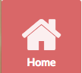
2. Reports - Entry point for viewing and publishing grain reports



1. Inbox - Useful for interpersonal communication and direct trade related messages amongst farmer extension personnel



1. Profile - Keeps the personal profile of the various farmers



1. Help - Provides education about the site and guidance for new users that try to onboard



**Advisory System / Informational Catalogue**

The Home View on the dashboard serves as the advisory component of the portal. It is comprised of an information catalogue with references mapping to each step involved in the value chain in an attempt to cover every stage in a given value chain.

The hierarchy presented comprises of the following six stages:

1. Harvesting
2. Threshing
3. Cleaning
4. Drying
5. Milling
6. Selling
7. Storing

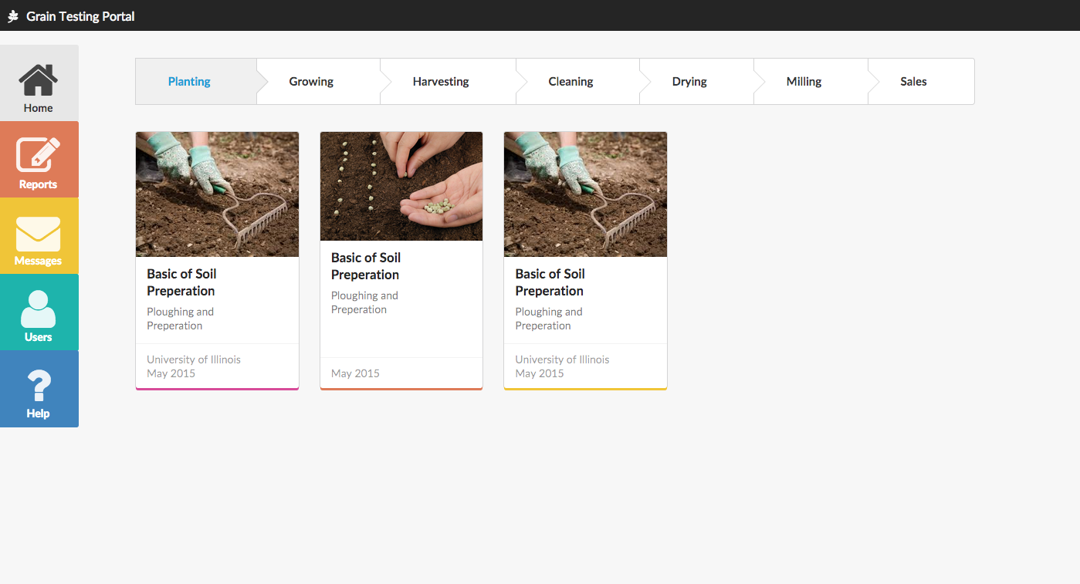

Figure 1

For each stage, the user is exposed to a collection of ‘cards’ which serve as references. Each card is essentially a reference into an informational article, tutorial video or just serves as a hyperlink to another online resource.

**Creating a Report**

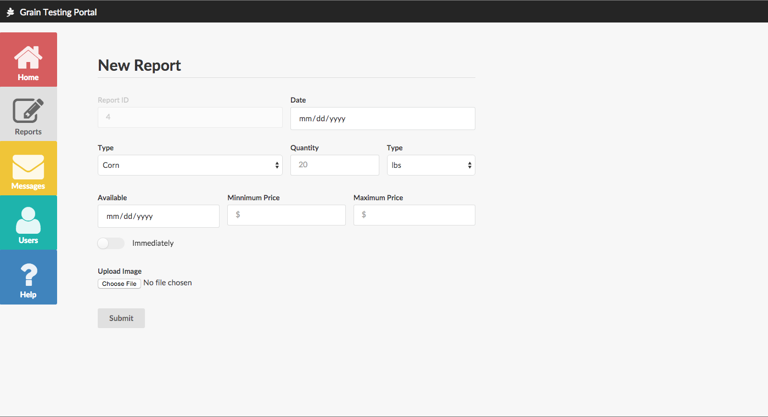

Figure 2

Once the user is ready to harvest his produce, he/she can go to the portal and ‘create a report’ in order to log information about it online. This report, created as a RFQ ([Request for Quotation](https://en.wikipedia.org/wiki/Request_for_quotation)) contains fields for a number of details such as type, quantity, etc. along with pictures of the harvested grain. Once this report is created and the farmer submits it, it goes to the user’s own report viewing page, from where he/she can publish it to the marketplace.

**Viewing and Publishing Reports**

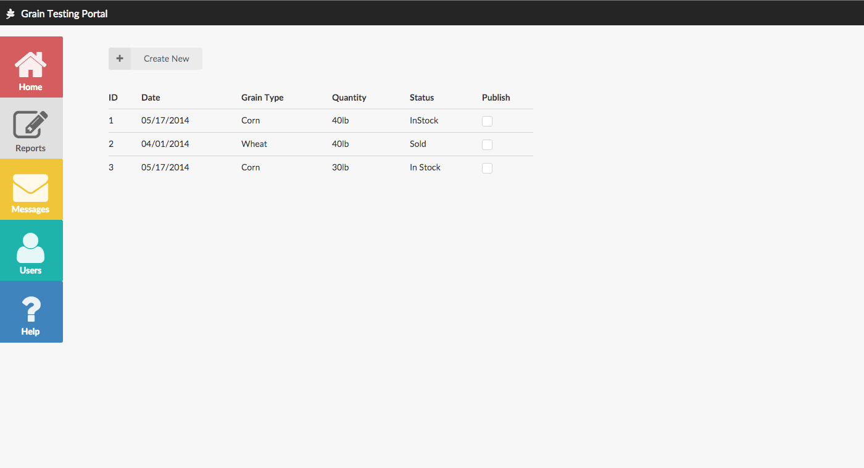

Figure 3

Once the report is created using the create report page, the farmer can come to the Reports viewing page to see all the reports created in the past. When there, the farmer can check the ‘Publish’ checkbox to publish the report to an online marketplace. This may look like an extra step in the process, however it helps the field workers to create a number of template reports for farmers, that farmers can later publish easily. Hence, in the earlier stages of portal adoption, farmers can be freed of the Create Report process.

Once the report is published from this pane and goes to the marketplace, it starts appearing at the buyer’s portal (not discussed here) from where a buyer can make a quote for trade. The messaging and quotation is discussed more in the “Connecting with Buyers” section below.

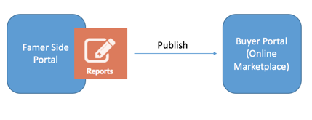

Figure 4

**Connecting with Buyers**

Once the grain report or the RFQ is on the market, it’s the buyers turn to act. Buyers are given the option to interact directly with the user (extension personnel) via In-App messaging i.e. Buyers can directly send messages using this portal.

Scenario wise, the vision is to make In-App messaging that works very much like a 1-to-1 messaging variant of [Twitter Direct Messaging](https://support.twitter.com/articles/14606). Buyers can contact farmers/sellers. Once they do so, an app notification is sent to the seller.

Additionally, email and SMS notifications are also configurable. It is possible for the user to configure his/her settings such that an SMS notification containing minimal information about the quote and contact information of the buyer is received. This ensures that even if the farmer does not have access to a public internet access terminal, he/she can get notified for trade and is able to act promptly.

We adopt the following architecture for the implementation of our project:

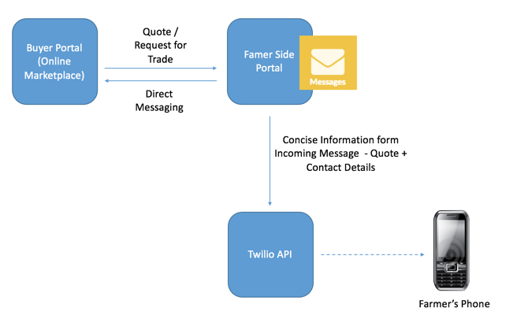

Figure 5

**Setting up Alerts**

Farmers are provided the option to set-up alerts for various activities that they intend to track. In order to set the alert, they need to provide a phone number and/or an email in their user profile.

The farmer can be alerted if there is a new message (or quotation) in their inbox. The farmer can then go to the portal and chat with the buyer. Such notifications help the farmer in responding quickly to the buyers and increase the engagement of the portal overall. On the technical side, this notification system is enabled via Twilio API Integration <https://www.twilio.com/api>.

Twilio APIs are extremely powerful RESTful APIs that provide great support for ad-hoc calling and texting. The development framework for this project: Django (discussed later) and Twilio interoperate well with each other ([Read more here](https://www.twilio.com/blog/2014/04/building-a-simple-sms-message-application-with-twilio-and-django-2.html)) and number of related messaging capabilities can be built with ease in the future.

**Obtaining Information from Bag Sensors**

When creating each report, the user is free to give it an ‘ID’. This is relevant especially for connectivity to grain bag sensors. If the farmer utilized a certain sensor kit to obtain information such as temperature, humidity, etc. from a bag of grain, he can provide the kit number or kit ID in the ‘ID’ field online when generating a report for the same grain. The cellular connectivity of the sensor kit can be used to fire a short message to the Twilio API hub that will further send this information to the Portal backend.

On the portal side of things, this message will be parsed and relevant information (numbers for temperature, humidity, etc.) will be mapped to the corresponding data for the report whose ID is associated with the sensor kit that sent the information.

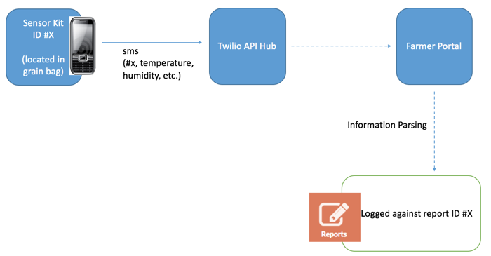

Figure 6

**Backend and Technologies Used**

This project is developed using a combination of Django, MySqlLite and HTML/CSS/JavaScript/JQuery. If seen from an MVC (Model View Controller) lens, MySqlLite is used for Models or Data Storage, Django (a framework built over Python) is used for Controllers or Business Logic and a combination of complimentary web technologies HTML/CSS/JavaScript/JQuery is for Views or User Interface.

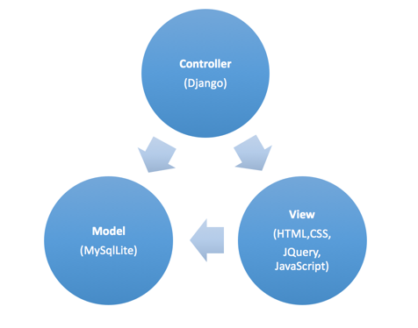

Figure 7

**Conclusion and Future Work**

Currently the portal allows sign up and login authentication for a user to gain access to the different views of the dashboard. The ‘Home’ and ‘Reports’ views, online marketplace and the Twilio handshake are functional according to the initial spec.

Future work should include further development of the online marketplace to help buyers make quotes and connect with farmers. Another area of research would be to discover a possible API to implement the ‘phone-in’ system for farmers with limited or no access to internet devices.